BHSTRAVEL Mulch Fundraiser Student Name and Trip: ______________________/____________
Order Form Orders and payment due: Tuesday, April 6th at 9:00 am
Checks payable to: BHS (include phone # on check)
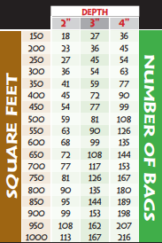
Black Mulch Chart
Customer  Information | Black  $5 | Brown  $5 | Red  $5 | Pine  $6 | Mulch  Total  Cost | Home  Delivery  Y/N* | Total  Quantity | Delivery Fee  $10 or $20 | Order Total | Paid?  Y/N
Name:
Phone:
Address:

Name:
Phone:
Address:

Name:
Phone:
Address:

Name:
Phone:
Address:

Name:
Phone:
Address:

Name:
Phone:
Address:

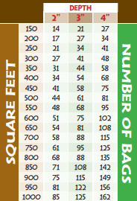
Brown/Red Mulch Chart
*Mulch will be delivered to BHS on the afternoon of Sunday, April 11th. Customers are responsible for picking up their
mulch unless they choose home delivery. Delivery fees: 1-10 bags for $10 and 11+ bags for $20.

Contact jcambell@mcssk2.org, jreese@mcssk12.org, or pcornell@mcssk12.org with any questions.

