Historical Society/BHSTRAVEL
VBC Concessions Fundraiser Information

How do I participate?
- Receive REMIND message from Coach Reese with available dates.
- EMAIL him what dates I would like to work from this list as well as the total number and names of the people who will be working (example: 2 - John Smith and mom Sally Smith)
- Receive confirmation through REMIND as well as the BHSTRAVEL website updates page on my selection to work.
- Show up and work (arrive 20 minutes before your schedule time in case you run into parking issues. Your shift usually begins 2 hours before the start time of the actual event)
- Check goes to BHS and is sent off to EF

VBS Expectations:

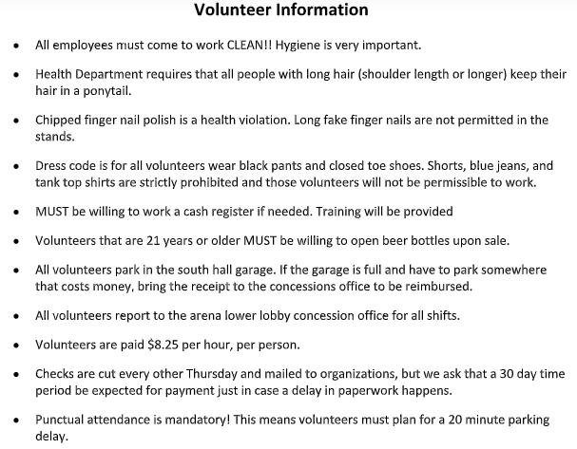
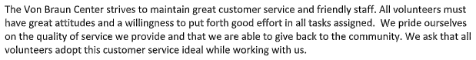
Please read the email information below sent by the VBC volunteer coordinator:

Here is the Havoc schedule.
ALL games volunteer schedule work hours are from 5 pm to 10 pm with the exception of:

- Feb 1st - 1 pm to 6 pm
- Feb 8th - 1 pm to 6 pm
- Feb 16th - 3 pm to 8 pm

Volunteers must wear black pants with tennis shoes or closed toe shoes. We will be providing them with a chef coat to cover their tops and to pull any long hair back. Also, tell them there is limited space for personal items. They will not be able to take their belongings to the Arena stand. They will have to either use one of our lockers that lock (limited quantity) or leave their belongings with us behind the counter. Of course we have complete surveillance so it will be safe but I just wanted to make sure they were aware of it. They can also bring a cup with them to get something to drink, but it will have to remain outside of the stand for health code reasons. I just always like to let them know beforehand. Just let me know when you have volunteers that want to volunteer for one of the Havoc games. Thanks again!

